Question personalisation - adding additional questions
This guide outlines how to add up to four additional questions to module feedback questionnaires and copy them to other modules.
You can access the Blue dashboard, either directly or through the link provided in the email inviting you to select additional questions.

Accessing Blue
- Log into the Blue dashboard
- Select Tasks at the top of the page
- Click Start now next to the module you want to add additional questions to.
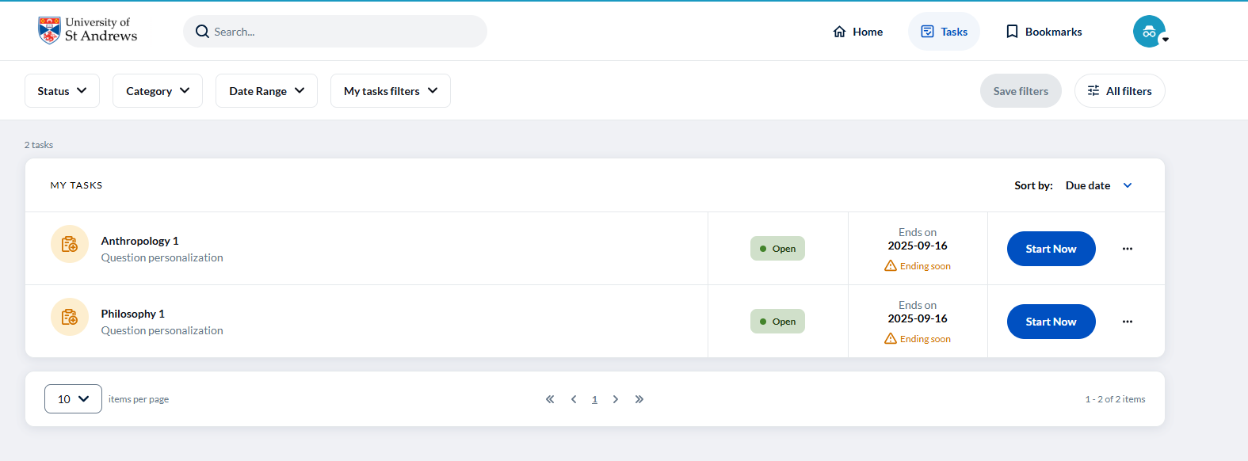
Once selections have been saved or submitted this will change to ‘Update’ or ‘View’.

Adding questions
- A list of the core questions will appear first – these cannot be changed.
- Use the drop-down menu to select View selectable to display the additional questions available for selection.
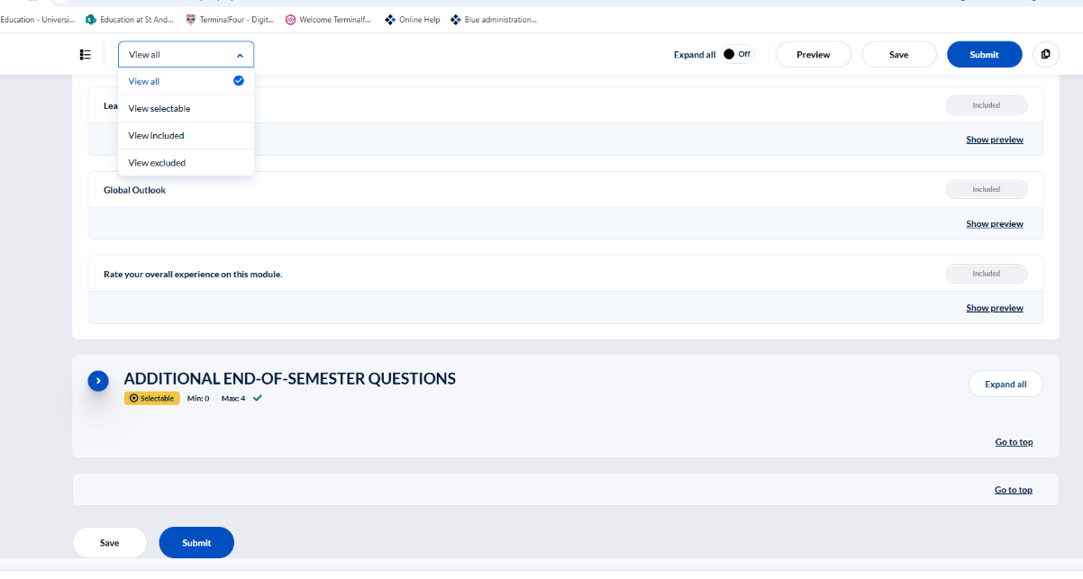
- Click Include next to each question you wish to add (up to four).
- Click Save to save your selections and return later to review and submit, or
- Click Submit to save and submit your selections.
- Use Preview to view the questionnaire as students will see it. Selections must be saved before previewing.
- You can modify your selections later by returning to Tasks and selecting Update or View next to the relevant module.
- After making changes, click Update to save them.
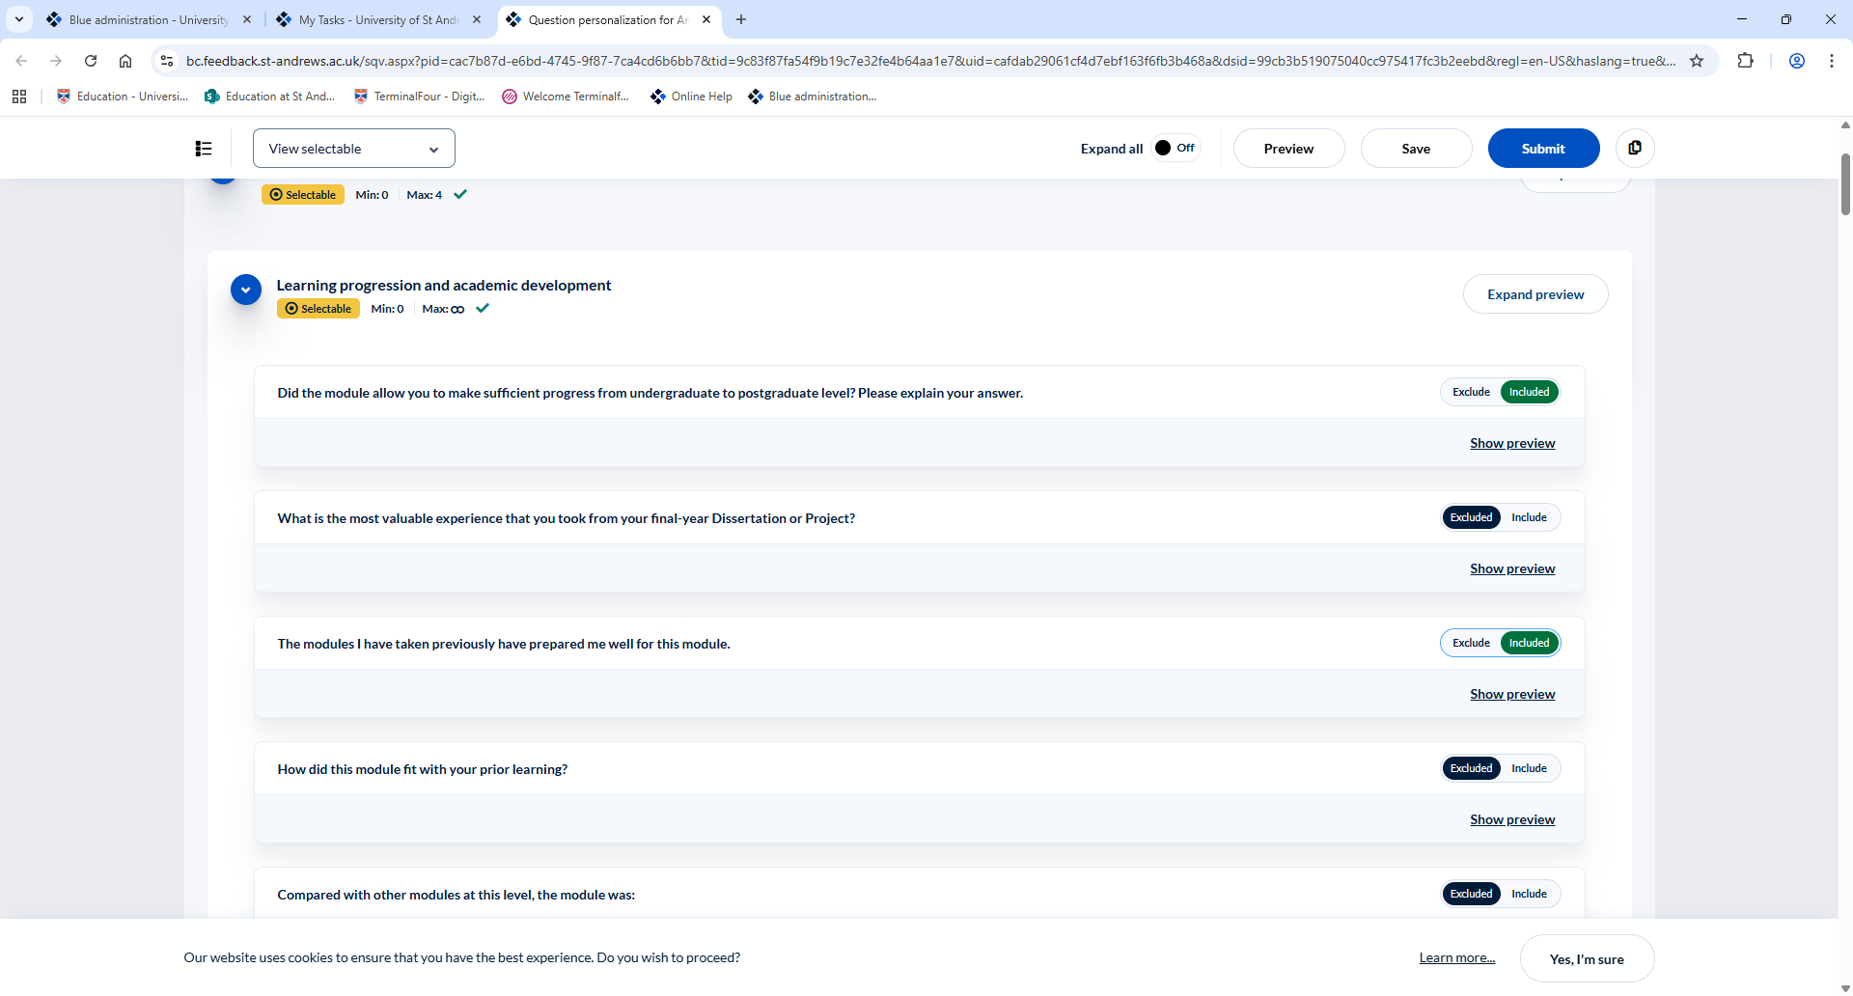
Once selections have been saved or submitted this icon will change to ‘Update’.

Copying questions to other modules
- Go to Tasks and click View next to the module with the additional questions you wish to copy.
- Click the Copy icon next to Update and select Copy selections to.
- In the pop-up window, click into the Search field and select the modules you wish to copy the questions to.
- Click Select (X), then Copy.
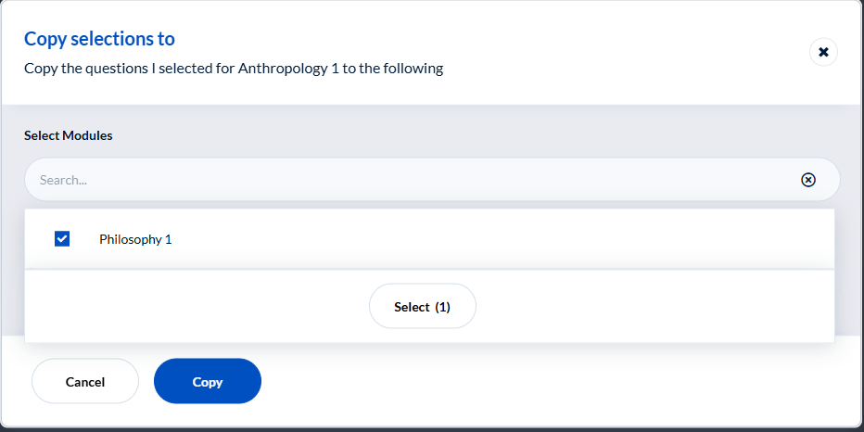
- Choose to either:

  - Copy the question to the selected subjects. This option allows you to copy the questions into each of the selected modules, then review and edit them as needed in each of the modules selected (you will need to return to the ‘Adding Questions’, section of this guidance to complete this process for each of the modules), or
  - Copy the question to the selected subjects and submit immediately. This option applies the questions to the selected modules without further review or modification.
- Click Copy and Submit, then Yes, I’m sure in the pop-up window, and then Update to complete the process.
- Close the window.
- Click Reload in Live update which will pop up at the bottom left of the page.
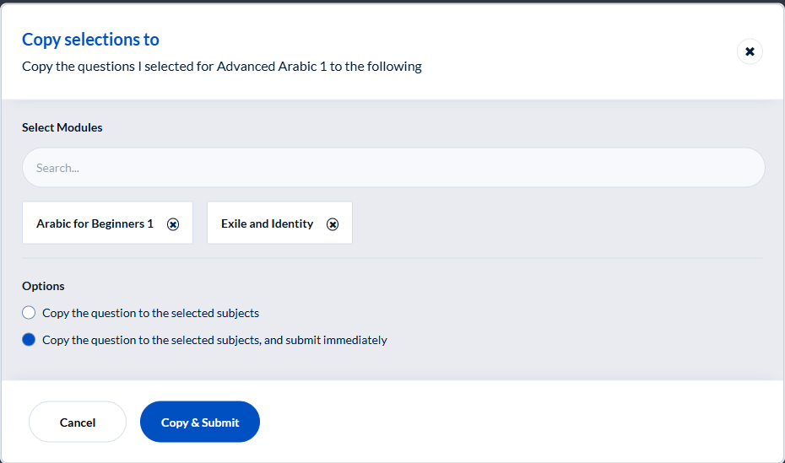
- The Tasks page will display modules as Completed once questions have been submitted for each module, and as Open for modules that still require questions to be added.
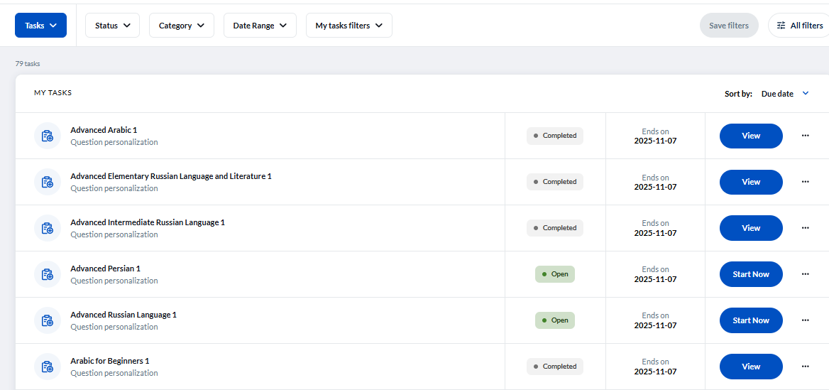
For further support, contact mfqsupport@st-andrews.ac.uk

